VLAN Trunk Protocol (VTP) reduces administration in a switched network. When you configure a new VLAN on one VTP server, the VLAN is distributed through all switches in the domain. This reduces the need to configure the same VLAN everywhere. VTP is a Cisco-proprietary protocol that is available on most of the Cisco Catalyst series products.
There is a Lab(about VTP) in the cisco CCNP BCMSN 642-812 exam.
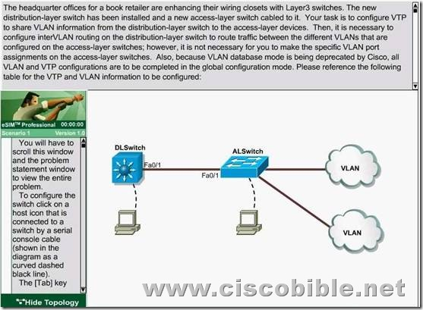

Requirements:
VTP Domain name | cisco
VLAN Ids | 20 | 21
IP Addresses | 172.16.71.1/24 | 172.16.132.1/24
These are your specific tasks:
1. Configure the VTP information with the distribution layer switch as the VTP server
2. Configure the VTP information with the access layer switch as a VTP client
3. Configure VLANs on the distribution layer switch
4. Configure inter-VLAN routing on the distribution layer switch
5. Specific VLAN port assignments will be made as users are added to the access layer switches in the future.
6. All VLANs and VTP configurations are to completed in the global configuration To configure the switch click on the host icon that is connected to the switch be way of a serial console cable.

Solutions:
1. Configure the VTP information with the distribution layer switch as the VTP server
DLSwitch#conf t
DLSwitch(config)#vtp mode server
DLSwitch(config)#vtp domain CISCO
2. Configure VLANs on the distribution layer switch
DLSwitch(config)#vlan 20
DLSwitch(config)#vlan 21
3.Configure Ip address for Vlans :
DLSwitch(config)#int vlan 20
DLSwitch(if-config)#ip add 172.16.71.1 255.255.255.0
DLSwitch(if-config)#no shut
DLSwitch(if-config)#int vlan 21
DLSwitch(if-config)#ip add 172.16.132.1 255.255.255.0
DLSwitch(if-config)#no shut
DLSwitch(if-config)#exit
4. Configure inter-VLAN routing on the distribution layer switch
DLSwitch#ip routing
DLSwitch#copy run start
5. Configure the VTP information with the access layer switch as a VTP client
ALSwitch#conf t
ALSwitch(config)#vtp mode client
ALSwitch(config)#vtp domain CISCO
ALSwitch(config)#exit
ALSwitch#copy run start
That is all, hope to helpful for you. Best Luck for ur BCMSN 642-812 Exam.
If you need the complete pass4sure test questions for 642-812 Exam, you can visit Latest Pass4sure 642-812,maye it helpful for ur exam!

