Hotspot 1 : super HSRP question
- DS1( Distribute switch 1) is the primary device for Vlan 101, 102, 105
- DS2 ( Distribute switch 2) is the primary device for Vlan 103 and 104
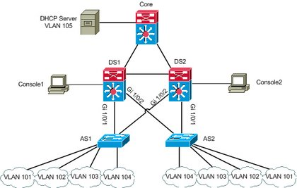
Question 1:
During routine maintenance, it became necessary to shutdown G1/0/1 on DS1. All other interface were up. During this time, DS1 remained the active device for Vlan 102's HSRP group. You have determined that there is an issue with the decrement value in the track command in Vlan 102's HSRP group. What need to be done to make the group function properly ?
A. The DS1's decrement value should be configured with a value from 5 to 15
B. The DS1's decrement value should be configured with a value from 9 to 15
C. The DS1's decrement value should be configured with a value from 11 to 18
D. The DS1's decrement value should be configured with a value from 195 to less than 205
E. The DS1's decrement value should be configured with a value from 200 to less than 205
F. The DS1's decrement value should be greater than 190 and less 200
Explanation:
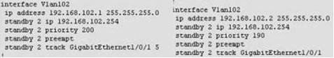
Use "show run" command to show. The left Vlan102 is console1 of DS1. Priority value is 200, we should decrement value in the track command from 11 to 18. Because 200 - 11 = 189 < 190 ( priority of Vlan102 on DS2 ).
Question 2:
During routine maintenance, G1/0/1 on DS1 was shutdown. All other interface were up. DS2 became the active HSRP device for Vlan101 as desired. However, after G1/0/1 on DS1 was reactivated. DS1 did not become the active HSRP device as desired. What need to be done to make the group for Vlan101 function properly ?
A. Enable preempt on DS1's Vlan101 HSRP group
B. Disable preempt on DS1's Vlan101 HSRP group
C. Decrease DS1's priority value for Vlan101 HSRP group to a value that is less than priority value configured on DS2's HSRP group for Vlan101
D. Decrease the decrement in the track command for DS1's Vlan 101 HSRP group to a value less than the value in the track command for DS2's Vlan 101 HSRP group.
Explanation:
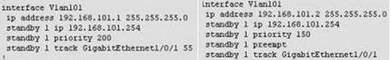
A is correct. All other answers is incorrect. Because Vlan101 on DS1 ( left ) disable preempt. We need enable preempt to after it reactive , it will be active device. If not this command, it never become active device.
Question 3:
DS2 has not become the active device for Vlan103's HSRP group even though all interfaces are active. As related to Vlan103's HSRP group. What can be done to make the group function properly ?
A. On DS1, disable preempt
B. On DS1, decrease the priority value to a value less than 190 and greater than 150
C. On DS2, increase the priority value to a value greater 241 and less than 249
D. On DS2, increase the decrement value in the track command to a value greater than 10 and less than 50.
Explanation:
( update soon ....)
Question 4:
If G1/0/1 on DS1 is shutdown, what will be the current priority value of the Vlan105's group on DS1 ?
A. 95
B. 100
C. 150
D. 200
Explanation:
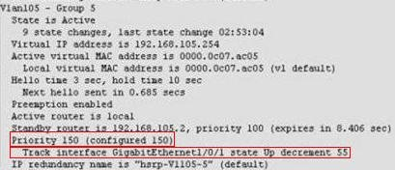
Priority is configured 150, Track is 55. So, if shutdown interface G1/0/1 --> 150 - 55 = 95.
Question 5:
What is the configured priority value of the Vlan105's group on DS2 ?
A. 50
B. 100
C. 150
D. 200
Explanation:
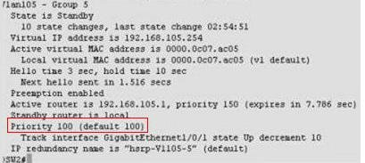
Use "show stantby brieft" command on console2 . Very easy to see priority of Vlan105 is 100.
Question 6:
During routine maintenance, it became necessary to shutdown G1/0/1 on DS1 and DS2. All other interface were up. During this time, DS1 became the active device for Vlan104's HSRP group. As related to Vlan104's HSRP group. What can be done to make the group function properly ?
A. On DS1, disable preempt
B. On DS2, decrease the priority value to a value less than 150
C. On DS1, increase the decrement value in the track command to a value greater than 6
D. On DS1, disable track command.
Explanation:
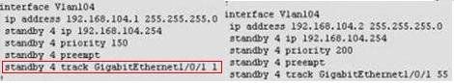
We should NOT disable preempt on DS1. By do that, you will make Vlan104's HSRP group fail function. Example: if we are disable preempt on DS1. It can not become active device when G1/0/1 on DS2 fail. In this question, G0/1/0 on DS1 & DS2 is shutdown. Vlan104 (left) : 150 - 1 = 149. Vlan104 (right) : 200 - 155 = 145. Result is priority 149 > 145 ( Vlan104 on DS1 is active). If increase the decrement in the track value to a value greater than 6 ( > or = 6). Vlan104 (left) : 150 - 6 = 144. Result is priority 144 < 145 ( vlan104 on DS2 is active).
Question 7:
Which statement is correct about the use of the virtual interface on a WLC :
A. Used to relay DHCP messages
B. Used to communicate with LAPs
C. Used to bring up LWAPP tunnels
D. Used to extend into the wireless client VLAN
Hotspot 2 : OSPF
The company and the company network have both been growing rapidly. Multiple adds, moves and changes have been applied to the network. Your boss at Certkiller .com, Miss Certkiller, has asked you to troubleshoot a recent OSPF synchronization problem that has arisen. There have been synchronization problems at separate locations in the OSPF area 0. There have been reported link failures during the rapid growth of the company network. You are required to resolve the OSPF problem. OSPF must be able to converge when the network changes.
Refer to the information above to answer the following 4 questions:
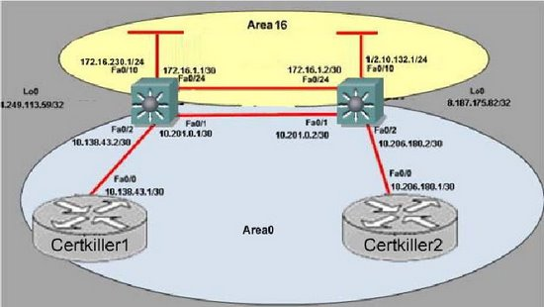
Question 1 :
Examine the following excerpt from the "show ip ospf" command on Certkiller A:
Area BACKBONE (0)
Number of interfaces in the this area is 1
Area has no authentication
SPF algorithm last executed 00:00:31.280 ago
SPF algorithm executed 5 times
Area ranges are
Number of LSA 13. Checksum Sum 0x16F0FD
Number of opaque link LSA 0. Checksum Sum 0x000000
Number of DCbitless LSA 0
Number of indication LSA 0
Number of DoNotAge LSA 0
Flood list length 0
Area 16
Number of interfaces in this area is 2
Area has message digest authentication
SPF algorithm last executed 00:00:34.928 ago
SPF algorithm executed 7 times
Area ranges are
Number of LSA 5. Checksum Sum 0x02FCD3
Number of opaque link LSA 0. Checksum Sum 0x000000
Number of DCbitless LSA 0
Number of indication LSA 0
Number of DoNotAge LSA 0
Flood list length 0
Based on the information shown above, what is most likely causing the different missing routes throughout the network?
A. Area 16 is configured with authentication.
B. Area 16 has been configured to use the same interfaces as Area 0.
C. Area 0 and Area 32 have been configured with mismatched LSA numbers.
D. Area 16 has been configured as a total stub network
E. Area 16 has been configured as a stub network
F. Area 0 is discontiguous.
G. None of the above
Explanation:
In this example, Certkiller1 shows that it only has 1 interface in area 0, while the network diagram shows that there should be two. This means that the Fa0/1 link is most likely gone down, creating a discontiguous backbone area. The link needs to be restored, or a virtual link needs to be created to fix this.
Question 2 :
Which configuration command on Certkiller 1 (with a similar command on Certkiller 2) will provide an immediate solution to the missing route problem?
A. no area 16 stub
B. no area 16 authentication message-digest
C. area 16 virtual-link 8.187.175.82
D. area 16 virtual-link 172.16.4.2
E. no area 16 stub no-summary
F. network 172.16.0.0.0.0.255.255 area 16
G. None of the above
Explanation:
A virtual link to an IP address (the loopback IP address in this case) on device Certkiller2 needs to be created. Similarly,Certkiller2 needs to also have this configured so that a virtual link to area 0 from area 16 can be created
Question 3:
The log of Certkiller 1 reports the following:
%LINEPROTO-5-UPDOWN: Line protocol on Interface FastEthernet0/1, changed state to down
%LINK-3-UPDOWN: Interface FastEthernet0/1, changed state to down
%OSPF-5-ADJCHG: Process 1, Nbr 8.187.175.82/32 on FasstEthernet0/1 from FULL to DOWN,
Neighbor Down: Interface down or detached
This event was anticipated due to maintenance; however, it resulted in excessive lost routes. Which route should be the only one removed from the routing tables of the routers?
A. 8.187.175.82/32
B. 10.138.43.0/30
C. 10.206.180.0/30
D. 4.249.113.59/32
E. 10.201.0.0/30
F. None of the above
Explanation:
The FastEthernet 0/1 link was the only physical link that went down, so in this case the network administrator had meant to only remove the 10.201.1.10/30 route associated with that link. However, the loopback IP address of Certkiller 2 is 8.187.175.82/32, which means that the neighbor relationship is down. When the FE 0/1 interface goes down, area 0 will effectively be cut in half creating a discontiguous backbone area.
Question 4:
The Certkiller 2 Router has lost connectivity to Certkiller 1. The following is Certkiller 1's current route table:
172.16.0.0/16 is variably subnetted, 3 subnets, 2 masks
O IA 172.16.240.0/24 [110/11] via 10.218.67.1, 00:00:03, FastEthernet0/0
O IA 172.16.209.0/24 [110/12] via 10.218.67.1, 00:00:03, FastEthernet0/0
O IA 172.16.4.0/30 [110/2] via 10.218.67.1, 00:00:03, FastEthernet0/0
10.0.0.0/30 is subnetted, 1 subnets
C 10.218.67.0 is directly connected, FastEthernet0/0
Which expected route is missing from Certkiller 1's route table based on the topology during the maintenance period?'
A. o 172.16.0.0 [110/2] via 10.218.67.1, 00:00:09, FastEthernet0/0
B. o IA 9.152.105.122 [110/3] via 10.218.67.1, 00:00:09, FastEthernet0/0
C. o IA 10.138.0.0 [110/3] via 10.218.67.1, 00:00:09, FastEthernet0/0
D. o IA 10.249.0.0 [110/2] via 10.218.67.1, 00:00:09, FastEthernet0/0
E. o IA 4.249.113.59 [110/2] via 10.218.67.1, 00:00:09, FastEthernet0/0
F. o 8.187.175.82 [110/3] via 10.218.67.1, 00:00:09, FastEthernet0/0
Explanation:
In this case, the missing route is the route to the loopback IP address of Certkiller 2. This loopback IP address was used for the virtual link, which was needed when the backbone area became discontiguous. If this route was missing, the virtual link would then go down and cause the additional routes to be missing.
Hotspot 3 : Spanning Tree
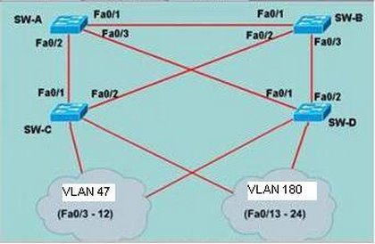
You study the network topology carefully, see exhibit. Then you connect to the SW-c ; issue the show spanning tree command. Please refer to the exhibit for the output. You are then required to answer the scenario questions using the information that is available.
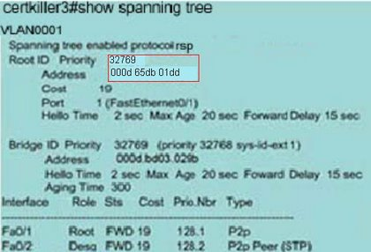
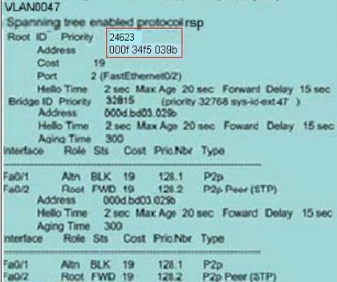
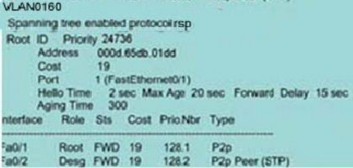
Question 1:
Which spanning Tree Protocol has been implemented on SW-B?
A. STP/IEEE 802.1D
B. MSTP/IEEE 802.1s
C. PVST+
D. PVRST
E. None of the above
Explanation:
802.1D has not been implemented since this is CST (Common Spanning Tree) which only allows one instance to be run at a time per Network. In this scenario there are multiple instances. It must be PVST+ since each instance only contains one VLAN.
Question 2:
Which bridge ID belongs to SW-B?
A. 32928 000d bd33 029b
B. 24623 000f 34f5 039b
C. 32928 000d bd03 029b
D. 32768 000d bd33 029b
E. 32769 000d 65db 01dd
F. 32815 000d bd03 029b
Explanation:
Root ports are ports that point to the Root Bridge. In the exhibit, under VLAN 47 we see that fa0/2 is a root port for VLAN 47. Since we assume that all paths have equal cost we can gather that the root ports destination is the root bridge itself. In this case the Root Bridge for VLAN 47 is SW-B and according the exhibit the MAC address is 24623 000f 34f5 039b
Question 3:
Which port role has interface Fa0/2 of SW-A adopted for VLAN 47?
A. Root port
B. Nondesigned port
C. Designated port
D. Backup port
E. Alternate port
Explanation:
Refer to Explanation for previous question. So far we know that SW-B is the Root Bridge for VLAN 47. We also see that SW-C is using fa0/2 as its root port. Therefore SW-A will use fa0/1 for its Root port and fa0/2 will be designated since fa0/1 on SW-C is blocking. Note: If one segment of SPT is in blocking statusthe distantend port is not. Otherwise BPDUs could not be transmitted and would negate the redundancy.
Question 4:
Which port state is interface Fa0/2 of SW-B in for VLANs 1 and 160?
A. Listening
B. Learning
C. Disabled
D. Blocking
E. Forwarding
F. Discarding
Explanation:
For VLAN 1 and 160 we can conclude that the Root Bridge is SW-A. With this in mind SW-B will use fa0/1 for its root port and block the other since the Cost will be lower. In this case it will block fa0/2 for both VLANs (and most likely fa0/3 also since SW-D is using fa0/1 as its root port).
Question 5:
Which bridge ID belongs to SW-A?
A. 32928 000d bd33 029b
B. 24623 000f 34f5 039b
C. 32928 000d bd03 029b
D. 32768 000d bd33 029b
E. 32769 000d 65db 01dd
F. 32815 000d bd03 029b
Explanation:
We see that in VLAN 1 and VLAN 160 that fa0/1 is the root port on SW-C. As previously discussed we know that root ports point to the root bridge and assuming equal cost from switch to root and the fact that no other port is root for either VLAN that SW-A is the Root Bridge and we can gleen the information for the exhibit which list the Bridge's VLAN.

