Acme is small export company that has an existing enterprise network comprised of 5 switches;
CORE,DSW1,DSW2,ASW1 and ASW2. The topology diagram indicates their desired pre-VLAN spanning tree mapping.
Previous configuration attempts have resulted in the following issues:
- CORE should be the root bridge for VLAN 20; however, DSW1 is currently the root bridge for VLAN 20.
- Traffic for VLAN 30 should be forwarding over the gig 1/0/6 trunk port between DSW1 and DSW2. However VLAN 30 is currently using gig 1/0/5.
- Traffic for VLAN 40 should be forwarding over the gig 1/0/5 trunk port between DSW1 and DSW2. However VLAN 40 is currently using gig 1/0/6.
You have been tasked with isolating the cause the these issuer and implementing the appropriate solutions. You task is complicated by the fact that you only have full access to DSW1, with isolating the cause of these issues and implementing the appropriate solutions, Your task is complicated by the fact that you only have full access to DSW1, with the enable secret password cisco. Only limited show command access is provided on CORE, and DSW2 using the enable 2 level with a password of acme. No configuration changes will be possible on these routers. No access is provided to ASW1 or ASW2.
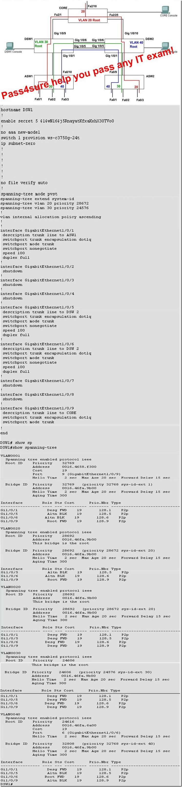

Solutions:
DSW1#conf t
DSW1(config)#spanning-tree vlan 20 priority 61440
DSW1(config)#int g1/0/5
DSW1(config-if)#spanning-tree vlan 40 cost 1
DSW1(config-if)#no shut
DSW1(config-if)#exit
DSW1(config)#int g1/0/6
DSW1(config-if)#spanning-tree vlan 30 port-priority 64
DSW1(config-if)#no shut
DSW1(config-if)#end
DSW1#copy run start

Verification：
DSW1# show spanning-tree vlan 20
DSW1# show spanning-tree vlan 40
DSW2# show spanning-tree vlan 30
That is all, hope to helpful for you. Best Luck for ur BCMSN 642-812 Exam.
If you need the complete pass4sure test questions for 642-812 Exam, you can visit Latest Pass4sure 642-812,maye it helpful for ur exam!

