Chọn đường đi
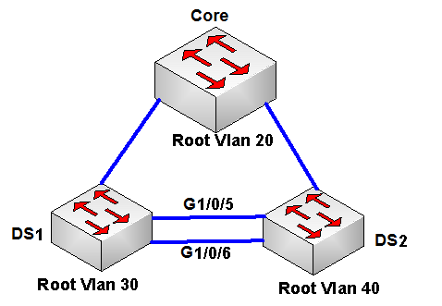
Chỉ được cấu hình trên DS1. DS còn lại chỉ được show (chú ý phải dùng enable 2 -> gõ vào pass. Vì Core và DS2 người ta chỉ cho mình priviledge 2)
1. Chắc chắn Core là RB cho vlan 20. Hiện tại DS1 là root cho vlan 20.

DS1(config)#spanning-tree vlan 20 priority 61440
DS1(config)#spanning-tree vlan 20 root secondary ( câu này thì cũng được nhưng mình đánh thì nó không cho Core làm BR cho vlan 20, nên phải đánh câu trên)

2.Trong vlan 30, giữa DS1 và DS2 đang đi bằng cổng g1/0/5. Yêu cầu đề là làm sao cho nó đi cổng g1/0/6 (DS1 là RB cho vlan 30)
DSW1(config)#int gig1/0/5
DSW1(config-if)#spanning-tree vlan 30 port-priority 240 (vì mặc định port priority của vlan 30 cho g1/0/5 là 128.5)
3. Vlan 40 giữa DS1 và DS2 đang đi bằng g1/0/6, yêu cầu cho nó đi bằng g1/0/5. Vì DS2 là RB vlan 40 cho nên ta không thể chỉnh tương tự như câu 2 được.
Vì thế ta phải chỉnh cost trên cổng g1/0/5
DSW1(config)#int gig1/0/5
DSW1(config-if)#spanning-tree vlan 40 cost 1 ( để cost đi vào cổng g1/0/5 nhỏ hơn cost đi vào cổng g1/0/6 => g1/0/5 ưu tiên hơn g1/0/6)

Dot1X
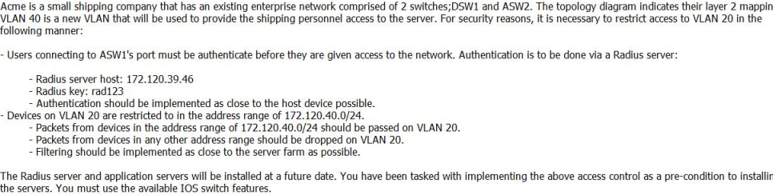
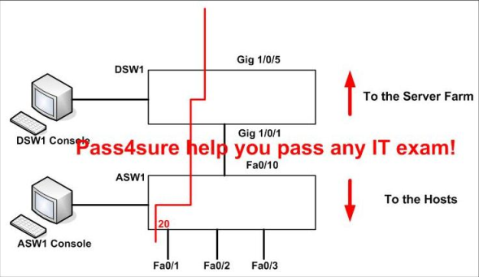

ASW1(config)#aaa new-model
ASW1(config)#radius-server host 172.120.39.46 key rad123
ASW1(config)#aaa authentication dot1x default group radius
ASW1(config)#dot1x system-auth-control

ASW1(config)#inter fastEthernet 0/1
ASW1(config-if)#dot1x port-control auto
ASW1(config-if)#exit
ASW1#copy run start

DSW1(config)#ip access-list standard 10
DSW1(config-ext-nacl)#permit 172.16.40.0 0.0.0.255
DSW1(config-ext-nacl)#exit

DSW1(config)#vlan access-map PASS 10
DSW1(config-access-map)#match ip address 10
DSW1(config-access-map)#action forward
DSW1(config-access-map)#exit
DSW1(config)#vlan filter PASS vlan-list 20

DSW1#copy run start

Hotspot 1 : super HSRP question
- DS1( Distribute switch 1) is the primary device for Vlan 101, 102, 105
- DS2 ( Distribute switch 2) is the primary device for Vlan 103 and 104
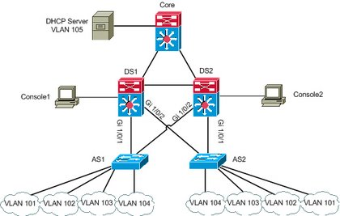
Question 1:
During routine maintenance, it became necessary to shutdown G1/0/1 on DS1. All other interface were up. During this time, DS1 remained the active device for Vlan 102's HSRP group. You have determined that there is an issue with the decrement value in the track command in Vlan 102's HSRP group. What need to be done to make the group function properly ?
A. The DS1's decrement value should be configured with a value from 5 to 15
B. The DS1's decrement value should be configured with a value from 9 to 15
C. The DS1's decrement value should be configured with a value from 11 to 18
D. The DS1's decrement value should be configured with a value from 195 to less than 205
E. The DS1's decrement value should be configured with a value from 200 to less than 205
F. The DS1's decrement value should be greater than 190 and less 200
Explanation:
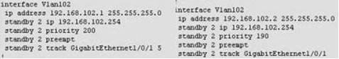
Use "show run" command to show. The left Vlan102 is console1 of DS1. Priority value is 200, we should decrement value in the track command from 11 to 18. Because 200 - 11 = 189 < 190 ( priority of Vlan102 on DS2 ).
Question 2:
During routine maintenance, G1/0/1 on DS1 was shutdown. All other interface were up. DS2 became the active HSRP device for Vlan101 as desired. However, after G1/0/1 on DS1 was reactivated. DS1 did not become the active HSRP device as desired. What need to be done to make the group for Vlan101 function properly ?
A. Enable preempt on DS1's Vlan101 HSRP group
B. Disable preempt on DS1's Vlan101 HSRP group
C. Decrease DS1's priority value for Vlan101 HSRP group to a value that is less than priority value configured on DS2's HSRP group for Vlan101
D. Decrease the decrement in the track command for DS1's Vlan 101 HSRP group to a value less than the value in the track command for DS2's Vlan 101 HSRP group.
Explanation:
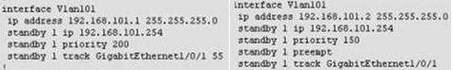
A is correct. All other answers is incorrect. Because Vlan101 on DS1 ( left ) disable preempt. We need enable preempt to after it reactive , it will be active device. If not this command, it never become active device.
Question 3:
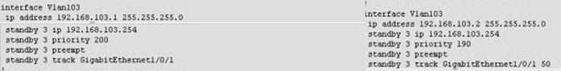
DS2 has not become the active device for Vlan103's HSRP group even though all interfaces are active. As related to Vlan103's HSRP group. What can be done to make the group function properly ?
A. On DS1, disable preempt
B. On DS1, decrease the priority value to a value less than 190 and greater than 150
C. On DS2, increase the priority value to a value greater 241 and less than 249
D. On DS2, increase the decrement value in the track command to a value greater than 10 and less than 50.
Explanation:
Không chọn B vì đề kêu SW2 luôn active Cho vlan 103. Nếu chọn B thì khi g1/0/1 down thì SW1 có thể làm active (trường hợp Sw1: 189, SW2 là 190, thì lúc này interface g1/0/1 down thì Sw1:179, SW2:140 => SW1 là active => trái yêu cầu đề bài)
( update soon ....)
Question 4:
If G1/0/1 on DS1 is shutdown, what will be the current priority value of the Vlan105's group on DS1 ?
A. 95
B. 100
C. 150
D. 200
Explanation:
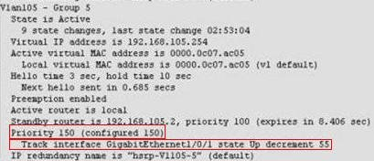
Priority is configured 150, Track is 55. So, if shutdown interface G1/0/1 --> 150 - 55 = 95.
Question 5:
What is the configured priority value of the Vlan105's group on DS2 ?
A. 50
B. 100
C. 150
D. 200
Explanation:
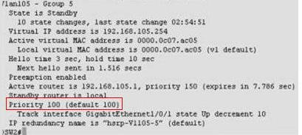
Use "show stantby brieft" command on console2 . Very easy to see priority of Vlan105 is 100.
Question 6:
During routine maintenance, it became necessary to shutdown G1/0/1 on DS1 and DS2. All other interface were up. During this time, DS1 became the active device for Vlan104's HSRP group. As related to Vlan104's HSRP group. What can be done to make the group function properly ?
A. On DS1, disable preempt
B. On DS2, decrease the priority value to a value less than 150
C. On DS1, increase the decrement value in the track command to a value greater than 6
D. On DS1, disable track command.
Explanation:
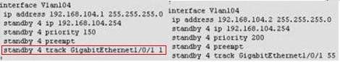
We should NOT disable preempt on DS1. By do that, you will make Vlan104's HSRP group fail function. Example: if we are disable preempt on DS1. It can not become active device when G1/0/1 on DS2 fail. In this question, G0/1/0 on DS1 & DS2 is shutdown. Vlan104 (left) : 150 - 1 = 149. Vlan104 (right) : 200 - 155 = 145. Result is priority 149 > 145 ( Vlan104 on DS1 is active). If increase the decrement in the track value to a value greater than 6 ( > or = 6). Vlan104 (left) : 150 - 6 = 144. Result is priority 144 < 145 ( vlan104 on DS2 is active).
Question 7:
Which statement is correct about the use of the virtual interface on a WLC :
A. Used to relay DHCP messages
B. Used to communicate with LAPs
C. Used to bring up LWAPP tunnels
D. Used to extend into the wireless client VLAN

Hotspot 3 : Spanning Tree
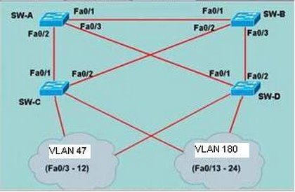
You study the network topology carefully, see exhibit. Then you connect to the SW-c ; issue the show spanning tree command. Please refer to the exhibit for the output. You are then required to answer the scenario questions using the information that is available.
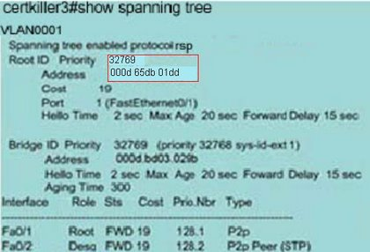
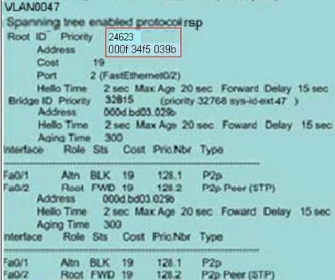
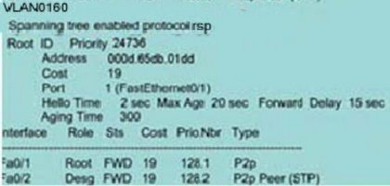
Question 1:
Which spanning Tree Protocol has been implemented on SW-B?
A. STP/IEEE 802.1D
B. MSTP/IEEE 802.1s
C. PVST+
D. PVRST
E. None of the above
Explanation:
802.1D has not been implemented since this is CST (Common Spanning Tree) which only allows one instance to be run at a time per Network. In this scenario there are multiple instances. It must be PVST+ since each instance only contains one VLAN.
Question 2:
Which bridge ID belongs to SW-B?
A. 32928 000d bd33 029b
B. 24623 000f 34f5 039b
C. 32928 000d bd03 029b
D. 32768 000d bd33 029b
E. 32769 000d 65db 01dd
F. 32815 000d bd03 029b
Explanation:
Root ports are ports that point to the Root Bridge. In the exhibit, under VLAN 47 we see that fa0/2 is a root port for VLAN 47. Since we assume that all paths have equal cost we can gather that the root ports destination is the root bridge itself. In this case the Root Bridge for VLAN 47 is SW-B and according the exhibit the MAC address is 24623 000f 34f5 039b
Question 3:
Which port role has interface Fa0/2 of SW-A adopted for VLAN 47?
A. Root port
B. Nondesigned port
C. Designated port
D. Backup port
E. Alternate port
Explanation:
Refer to Explanation for previous question. So far we know that SW-B is the Root Bridge for VLAN 47. We also see that SW-C is using fa0/2 as its root port. Therefore SW-A will use fa0/1 for its Root port and fa0/2 will be designated since fa0/1 on SW-C is blocking. Note: If one segment of SPT is in blocking statusthe distantend port is not. Otherwise BPDUs could not be transmitted and would negate the redundancy.
Question 4:
Which port state is interface Fa0/2 of SW-B in for VLANs 1 and 160?
A. Listening
B. Learning
C. Disabled
D. Blocking
E. Forwarding
F. Discarding
Explanation:
For VLAN 1 and 160 we can conclude that the Root Bridge is SW-A. With this in mind SW-B will use fa0/1 for its root port and block the other since the Cost will be lower. In this case it will block fa0/2 for both VLANs (and most likely fa0/3 also since SW-D is using fa0/1 as its root port).
Question 5:
Which bridge ID belongs to SW-A?
A. 32928 000d bd33 029b
B. 24623 000f 34f5 039b
C. 32928 000d bd03 029b
D. 32768 000d bd33 029b
E. 32769 000d 65db 01dd
F. 32815 000d bd03 029b
Explanation:
We see that in VLAN 1 and VLAN 160 that fa0/1 is the root port on SW-C. As previously discussed we know that root ports point to the root bridge and assuming equal cost from switch to root and the fact that no other port is root for either VLAN that SW-A is the Root Bridge and we can gleen the information for the exhibit which list the Bridge's VLAN.

Câu mới: có 4 câu, nhưng hiện mình chỉ nhớ 3 câu
1 câu mới về VRRP, nó show cho mình thấy lội, thực ra là do trùng IP trên cổng làm VRRP giữa R1 và R2
1 câu mới về HSRP (nó show lên cho bạn thấy lỗi)
1 câu mới về GLBP: đề hỏi GLBP truyền thông tin giữa các router như thế nào.
Chọn UDP 3222.

1 câu gì nữa ko nhớ.

Câu Sai.
139 trong p3.10 hình P4S-SB đáng lẽ phải là Hub mới đúng.
169 D là chính xác.

