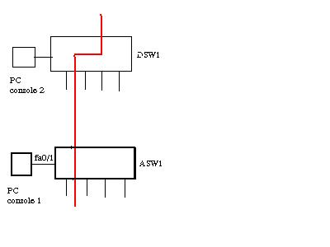
(this image is similar with the real exam )
- Radius server : 172.16.149.1
- Key : rad123
- Server: Vlan 40 is a new vlan which is used to access server
- User: vlan 20, connect to ASW1
- Ip users: 172.16.40.0/24

Config
!!!! Console to ASW1 from PC console 1
ASW1(config)#aaa new-model
ASW1(config)#radius-server host 172.16.149.1 key rad123
ASW1(config)#aaa authentication dot1x default group radius
ASW1(config)#dot1x system-auth-control

ASW1(config)#inter fastEthernet 0/1
ASW1(config-if)#dot1x port-control auto
ASW1(config-if)#exit
ASW1#copy run start

!!! Console to DSW1 from PC console 2

DSW1(config)#ip access-list standard 10
DSW1(config-ext-nacl)#permit ip 172.16.40.0 0.0.0.255
DSW1(config-ext-nacl)#exit

DSW1(config)#vlan access-map PASS 10
DSW1(config-access-map)#match ip address 10
DSW1(config-access-map)#action forward
DSW1(config-access-map)#exit
DSW1(config)#vlan access-map PASS 20
DSW1(config-access-map)#action drop
DSW1(config-access-map)#exit
DSW1(config)#vlan filter PASS vlan-list 40

DSW1#copy run start

