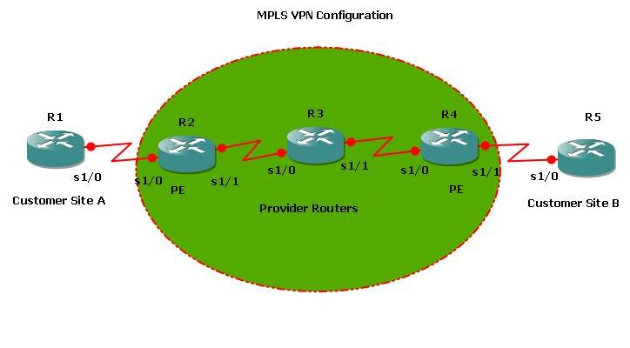
Configuration on Router R1
In global configuration Mode:
R1(config)# interface Loopback0
R1(config)#ip address 10.1.1.1 255.255.255.255
R1(config)#router ospf 1
R1(config-router) # network 1.1.1.1 0.0.0.0 area 0
R1(config-router) #network 10.1.1.1 0.0.0.0 area 0
A (config-router) #end
Configuration on Router R2
In global configuration Mode:
R2(config)# ip cef
R2(config)#mpls label protocol ldp
R2(config)# ip vrf site1
R2(config-vrf)#rd 1:1
R2(config-vrf)#route-target export 1:1
R2(config-vrf)#route-target import 1:1
R2(config)#interface Loopback0
R2(config)#ip address 20.1.1.1 255.255.255.255
R2(config)#interface Serial1/0
R2(config)# ip vrf forwarding site1
R2(config)#ip address 1.1.1.2 255.0.0.0
R2(config)#interface Serial1/1
R2(config)# mpls ip
R2(config)#ip address 2.1.1.1 255.0.0.0
R2(config)# router ospf 10 vrf site1
R2(config-router)# redistribute bgp 1 subnets
R2(config-router)# network 1.1.1.2 0.0.0.0 area 0
R2(config)# router ospf 1
R2(config-router)# network 2.1.1.1 0.0.0.0 area 0
R2(config-router)# network 20.1.1.1 0.0.0.0 area 0
R2(config)# router bgp 1
R2(config-router)# bgp router-id 20.1.1.1
R2(config-router)# neighbor 40.1.1.1 remote-as 1
R2(config-router)# neighbor 40.1.1.1 update-source Loopback0
R2(config-router)# address-family vpnv4
R2(config-router-af)# neighbor 40.1.1.1 activate
R2(config-router-af)# neighbor 40.1.1.1 send-community extended
R2(config-router-af)# exit
R2(config-router)# address-family ipv4 vrf site1
R2(config-router-af)# redistribute ospf 10 vrf site1 match internal external 1 external 2
R2(config-router-af)# end
Configuration on Router R3
In global configuration Mode:
R3(config)# ip cef
R3(config)#mpls label protocol ldp
R3(config)#interface Loopback0
R3(config)#ip address 30.1.1.1 255.255.255.255
R3(config)#interface Serial1/0
R3(config)# mpls ip
R3(config)#ip address 2.1.1.2 255.0.0.0
R3(config)#interface Serial1/1
R3(config)# mpls ip
R3(config)#ip address 3.1.1.1 255.0.0.0
R3(config)# router ospf 1
R3(config-router)# network 2.1.1.2 0.0.0.0 area 0
R3(config-router)# network 3.1.1.3 0.0.0.0 area 0
R3(config-router)# network 30.1.1.1 0.0.0.0 area 0
R3 (config-router) #end
Configuration on Router R4
In global configuration Mode:
R4(config)# ip cef
R4(config)#mpls label protocol ldp
R4(config)# ip vrf site1
R4(config-vrf)#rd 1:1
R4(config-vrf)#route-target export 1:1
R4(config-vrf)#route-target import 1:1
R4(config)#interface Loopback0
R4(config)#ip address 40.1.1.1 255.255.255.255
R4(config)#interface Serial1/1
R4(config)# ip vrf forwarding site1
R4(config)#ip address 4.1.1.1 255.0.0.0
R4(config)#interface Serial1/0
R4(config)# mpls ip
R4(config)#ip address 3.1.1.2 255.0.0.0
R4(config)# router ospf 10 vrf site1
R4(config-router)# redistribute bgp 1 subnets
R4(config-router)# network 4.1.1.2 0.0.0.0 area 0
R4(config)# router ospf 1
R4(config-router)# network 3.1.1.2 0.0.0.0 area 0
R4(config-router)# network 40.1.1.1 0.0.0.0 area 0
R4(config)# router bgp 1
R4(config-router)# bgp router-id 40.1.1.1
R4(config-router)# neighbor 40.1.1.1 remote-as 1
R4(config-router)# neighbor 40.1.1.1 update-source Loopback0
R4(config-router)# address-family vpnv4
R4(config-router-af)# neighbor 20.1.1.1 activate
R4(config-router-af)# neighbor 20.1.1.1 send-community extended
R4(config-router-af)# exit
R4(config-router)# address-family ipv4 vrf site1
R4(config-router-af)# redistribute ospf 10 vrf site1 match internal external 1 external 2
R4(config-router-af)# end
Configuration on Router R5
In global configuration Mode:
R5(config)# interface Loopback0
R5(config)#ip address 50.1.1.1 255.255.255.255
R5(config)#router ospf 1
R5(config-router) # network 4.1.1.2 0.0.0.0 area 0
R5(config-router) #network 50.1.1.1 0.0.0.0 area 0

